**Part 1.**

1. Create programming_assignment_db schema in MySQL
2. Run testDatabase.sql script provided to load data into tables

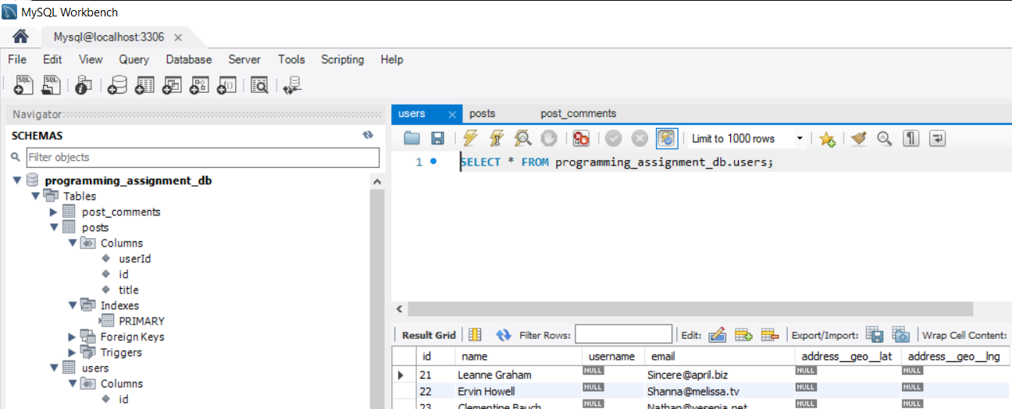

**Part 2.**

*Files: fill_users_table.py*

1. Call https://jsonplaceholder.typicode.com/users using Postman to view user data. User Json data (below) provides full user profile. However, we only need to extract three fields to update missing user table data:

- username

- address__geo__lat

- address__geo__lng

{

    "id": 1,

    "name": "Leanne Graham",

    "username": "Bret",

    "email": "Sincere@april.biz", Will be used to find correct user in database

    "address": {

      "street": "Kulas Light",

      "suite": "Apt. 556",

      "city": "Gwenborough",

      "zipcode": "92998-3874",

      "geo": {

        "lat": "-37.3159",

        "lng": "81.1496"

      }

    },

    "phone": "1-770-736-8031 x56442",

    "website": "hildegard.org",

    "company": {

      "name": "Romaguera-Crona",

      "catchPhrase": "Multi-layered client-server neural-net",

      "bs": "harness real-time e-markets"

    }

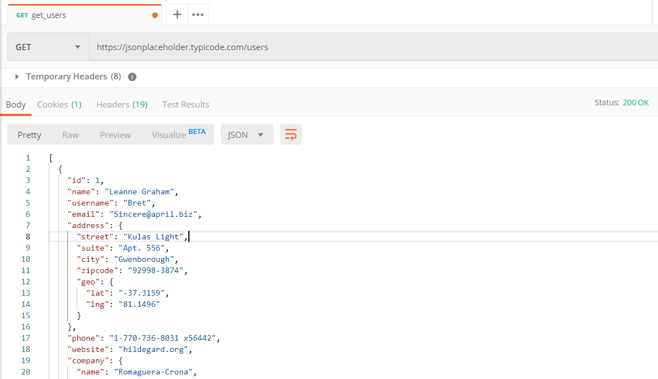

Run script to loop through users returned by api, then update users table.

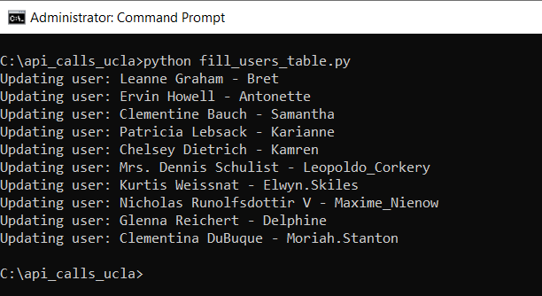

While we have Json for each user, use user email to pull that user’s id (PK from users table) and use that id to update posts table. This is done by calling <https://jsonplaceholder.typicode.com/posts?userId=4> for each user inside for loop and building SQL (in clause for posts table that contains all the post ids for that user) for update.

**SQL and program run results.**

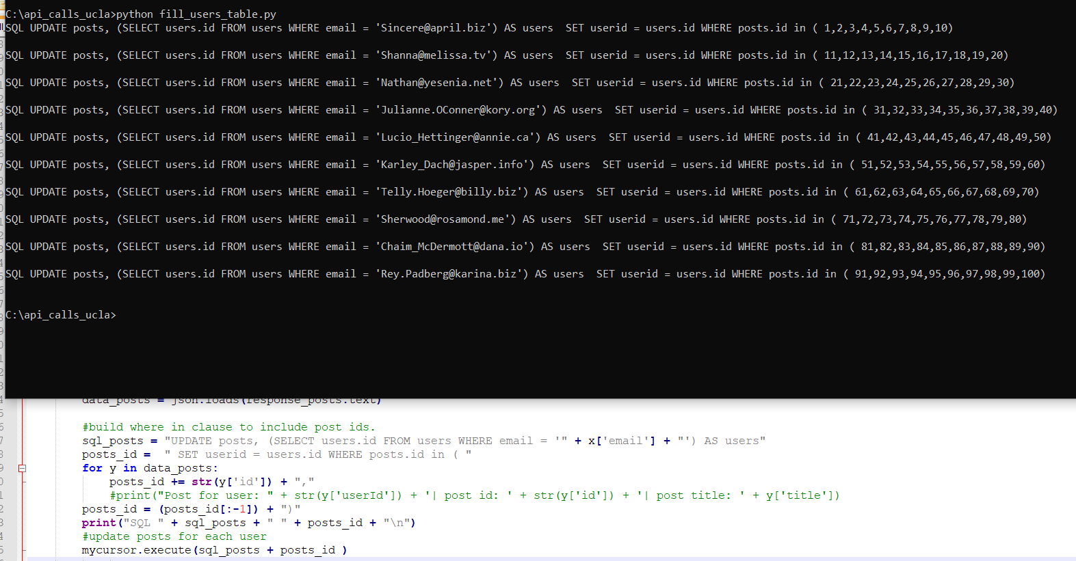

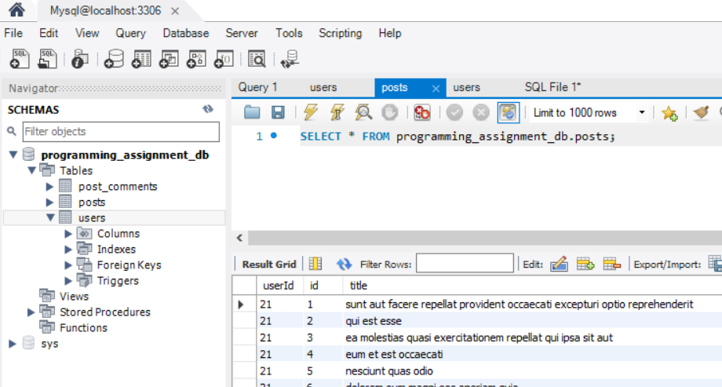

**Part 3.**

*Files: build_commenters_report.py*

1. Run script to create distance function f_distance.sql
2. Run script to create view that supplies the report’s data v_users_commenters.sql
3. Execute *build_commenters_report.py*

To build excel report xlsxwriter package needs to be installed.

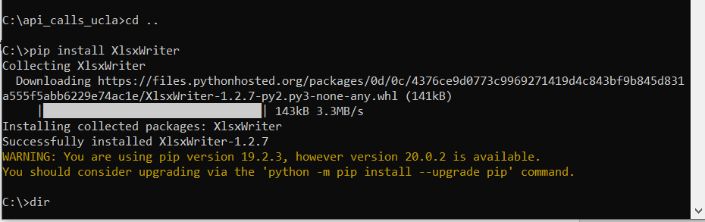

To create excel report, I decided to use a view that can be reused to accomplish task 4 and 5.

The view used function distance to calculate differences between latitude and longitude sets.

View used to pull frequent commenters

CREATE VIEW V_users_commenters

AS

select dt.* , uu.username commenter_username, uu.id commenter_id,

-- calculate distance

uu.address__geo__lat commenter_lat, uu.address__geo__lng commenter_lng,

distance(poster_lat, poster_lng, uu.address__geo__lat, uu.address__geo__lng) distance

from users uu inner join

(

SELECT p.userid poster_id, u.username poster_username, u.address__geo__lat poster_lat, u.address__geo__lng poster_lng,

pc.email commenter_email, count(0) nr_of_times_commented

FROM posts p, post_comments pc, users u

where p.id = pc.postId

and p.userId = u.id

group by p.userid , pc.email

having count(0) >= 3

) as dt

on uu.email = dt.commenter_email

order by nr_of_times_commented desc

Function used to calculate distance

DELIMITER $$

CREATE FUNCTION `Distance`(

lat1 FLOAT, lon1 FLOAT,

lat2 FLOAT, lon2 FLOAT

) RETURNS float(10,3)

NO SQL

DETERMINISTIC

BEGIN

RETURN DEGREES(ACOS( COS(RADIANS(lat1)) * COS(RADIANS(lat2)) * COS(RADIANS(lon2) - RADIANS(lon1)) + SIN(RADIANS(lat1)) * SIN(RADIANS(lat2)) ));

END$$

DELIMITER ;

Generated report.

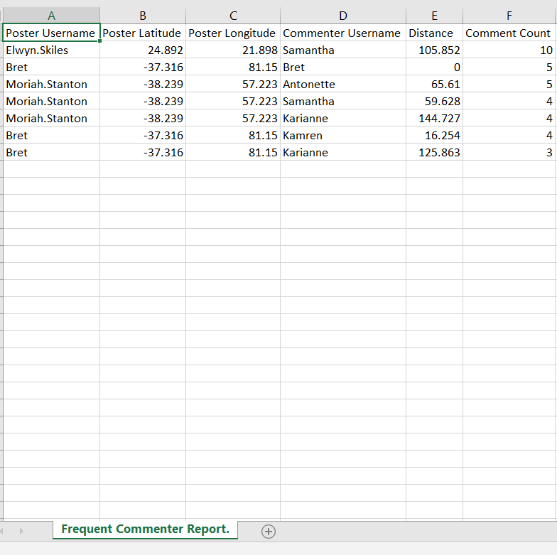

**Part 4.**

Install flask to build API

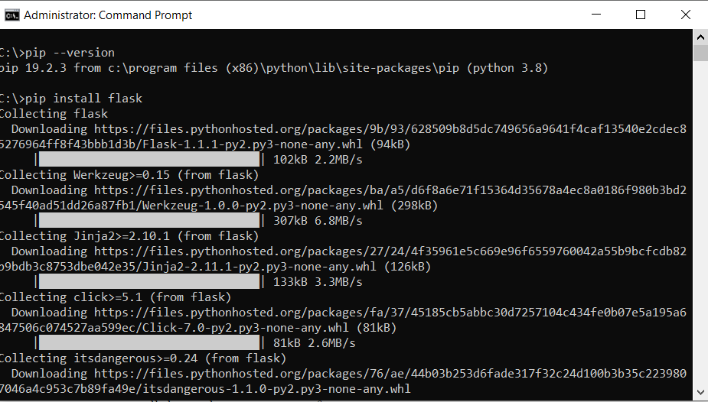

API run page

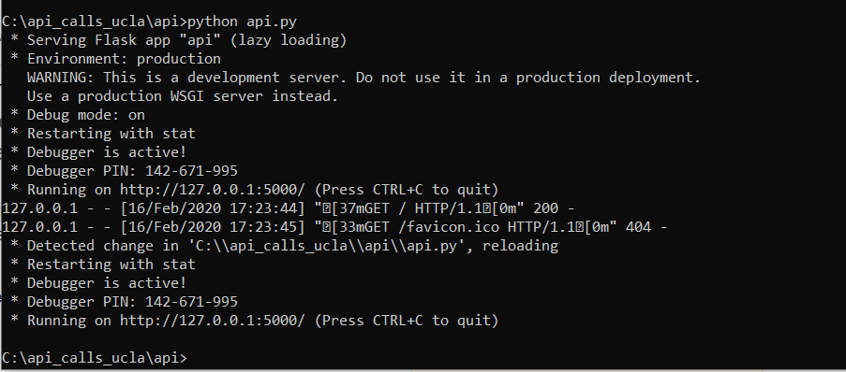

Testing API using PostMan

http://127.0.0.1:5000/api/v1/posters?id=21

Note: there 3 frequent users records – json needs to be modified to loop through rest of frequent users and add elements – struggled with formatting here (for this report user Bret has 3 frequent users).

